**HTML LISTS**

* Lists in HTML are of two types :

1. **ORDERED LISTS** :

* Ordered lists follow a particular sequence and are numbered.
* They are represented by <ol> tag.

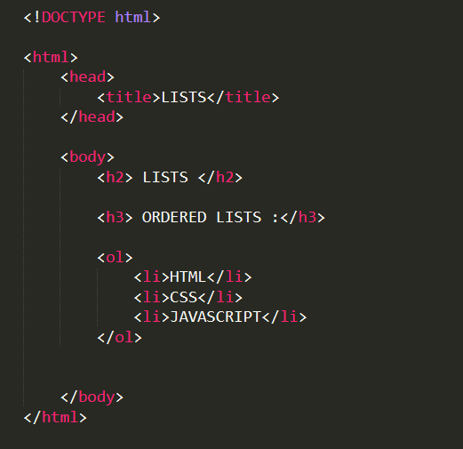

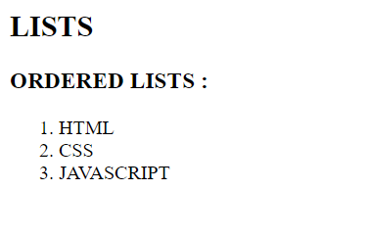

1. **UNORDERED LISTS** :

* Unordered lists are bullet-ed lists.
* They are represented by <ul> tag.

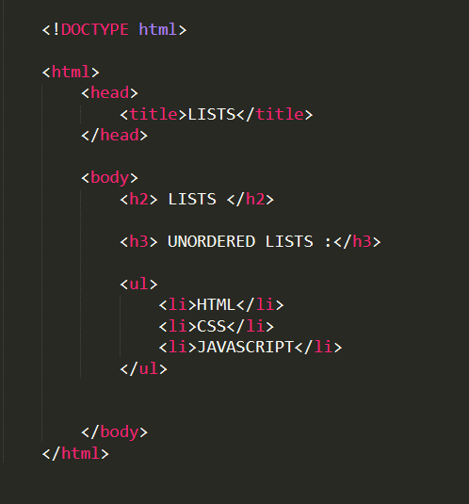

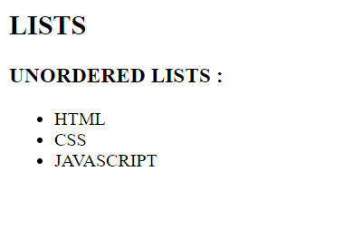

**NOTE** : Each element of the list is written within the <li> </li> tag which indicates list item.